REGIONAL DISTRICT OF CENTRAL KOOTENAY
Development Permit Report

Date of Report: | April 2, 2019
Date & Type of Meeting: | Choose Meeting Type Here
Author: | Dana Hawkins, Planner
Subject: | DEVELOPMENT PERMIT (GILL – JOHNSONS LANDING)
File:  To: | 06/4260/20/2019/DP1902D-05680.200-GILL-dp000086  General manager of development services
X-reference:

SECTION 1: EXECUTIVE SUMMARY
The purpose of this report is to recommend that the General Manager of Development Services issue a Development Permit (DP) for a residence at Johnson Landing Road in Electoral Area D. A DP is required by the Electoral Area D Comprehensive Land Use Bylaw No. 2435, 2016 as the proposal includes vegetation clearing and construction within 30 meters (98 feet) of Kootenay Lake. The purpose of this Watercourse Development Permit Area is to regulate foreshore development to protect aquatic habitat, and to conserve, enhance and restore watercourses and their riparian areas.
SECTION 2: BACKGROUND / ANALYSIS
Owners: | Gary Gill and Colleen Yurko | Parcel size: | 1.07 hectares (2.65 acres)
Legal description: | LOT 1 DISTRICT LOT 6810 AND 9039 KOOTENAY DISTRICT PLAN NEP90758  (PID: 028-211-189)
OCP designation: | Remote Residential (RR) | Zoning: | n/a
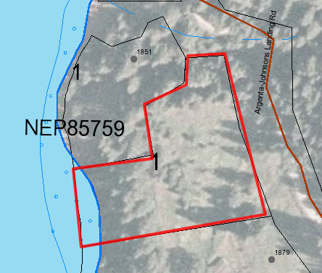
Figure 1: Orthophoto of subject property.
PROPOSAL
A residence, boathouse, septic field, domestic water system, and driveway are proposed within the Watercourse Development Permit Area (WDPA). Under the Electoral Area D Comprehensive Land Use Bylaw, the WDPA extends 30 meters upland of the natural boundary of Kootenay Lake. The purpose of the WDPA is to “regulate development activities in watercourses, lakes and wetlands and their adjacent riparian areas so as to protect aquatic habitat, and to conserve, enhance and, where necessary, restore watercourses and their riparian areas.” The proposal was accompanied by an Environmental Assessment Report by Masse Environmental (please see Schedule 2 in Attachment A).

The main proposed building is a single storey home and patio, covering a total area of 91.4 m². The proposed building site is on a ~14% slope and is mostly cleared of trees. A new road has been constructed to access the home site from Johnson’s landing to the east. A 28.2 m² boathouse is proposed north of the cabin.

REFERRAL COMMENTS
The application was referred to internal and external public agencies and to landowners of the 5 parcels within 100 metres of the subject property. The following comments were received:

Interior Health Authority, Environmental Health Officer, February 14, 2019
Thank you for the opportunity to provide comments on the above referenced Development Permit Application from the viewpoint of our policies and regulations governing onsite sewerage dispersal systems and water supply. The applicant is requesting a development permit for the construction of an access, boat house, and residence including installation of a domestic water system and a septic system.

This office is not opposed to the proposed development, however, please be advised that the covenant referenced in the application must be released or amended prior to construction. The applicant may contact this office for further information.

In addition, if the applicant is proposing a domestic water system that meets the definition of a “water supply system” as defined in the Drinking Water Protection Act, the applicant must obtain the relevant permits in consultation with a drinking water officer and Interior Health.

If you have any questions, concerns or require additional explanation, please email HBE@InteriorHealth.ca or phone toll free at 1-855-744-6328, then choose the HBE option.

Ministry of Forests, Lands and Natural Resource Operations and Rural Development, Habitat Officer, March 6, 2019
Any works within or adjacent to a stream are subject to the Provincial Water Sustainability Act. This includes Water Licences for domestic use or Changes in and About a Stream. Please review the Kootenay Region’s Terms and Conditions for Instream works available at: https://www2.gov.bc.ca/assets/gov/environment/air-land-water/water/working-around-water/terms_conditions_kootenays.pdf
and instream fish windows at:
https://www2.gov.bc.ca/assets/gov/environment/air-land-water/water/working-around-water/work_window_kootenays.pdf
to ensure that you can abide by these guidelines.

Ministry of Transportation and Infrastructure, Development Technician, February 22, 2019
MOTI does not have any concerns with the proposal from a transportation perspective. Thanks for the opportunity to review.

Archeology Branch, Archeologist, March 22, 2019
The property with PID 028211189, legally described as LOT 1 DISTRICT LOT 6810 AND 9039 KOOTENAY DISTRICT PLAN NEP90758 has archaeological site EaQf-9 recorded in the approximate centre of the property. The site is mapped as a 1x1 m square as there was no absolute provenance for the artifacts collected by Mr. Weir (the property owner at the time the site was recorded). According to Joel Kinzie (a permit officer here at the Branch who went and visited Mr. Weir in 2000) Mr. Weir had an extensive collection of stone artifacts that he collected “on his beach walks”. He didn’t have any specific locations for any of the artifacts that he collected.

While the site is mapped there – it’s not really a site – more of a holding place for the records about Mr. Weir’s collection. If the property owner finds anything suspected to be archaeological in nature, they should stop work and contact the Archaeology Branch. Things to look out for would be stone tools (arrowheads, ground stone tools, flakes of stone that don’t resemble the local rocks), burnt soil, charcoal or ash (signs of camp fires or cooking fires), fire-broken rock – when rocks are heated repeatedly they fracture with angular facets – they often also show evidence of having been part of a camp fire ring or similar. Bones of any kind should be reported unless they have clear saw marks (from modern butchering).

Area A Advisory Planning Committee, March 12, 2019
The Area D APC did not choose to meet on this DP. We have no comments.

APC Member, March 11, 2019
I don’t see anything in the application that raises serious flags for me. I do, however, have one question about the installation of the upgradient septic tank. The tank’s proposed location, which is a modification from original plans, meets the 30m setback requirement under applicable legislation. My question is whether any final decisions about the new location will be subject to the results of a percolation test, which the proponent commits to getting done in 2019. Should there ever be a need to know how fast the contents of the septic tank will make it to the lake, that information could be critical to effective emergency response planning.

APC Member, February 11, 2019
This application looks great to me, I don’t live in Johnson’s landing, but as long as the adjacent property owners are good switch it I’d like to see more development in the area.

No comments were received from:
- RDCK Building Services
- RDCK Fire Services
- Kootenay Lake Partnership
- Area D Director
- Neighbouring property owners

KOOTENAY LAKE SHORELINE GUIDANCE DOCUMENT

No Provincial application is required, as the proposed development is setback 15 meters from the natural boundary of Kootenay Lake. This segment of the Kootenay Lake shoreline has a high Aquatic Habitat Index Rating, has aquatic site sensitivity, and has emergent vegetation present. The area has high archaeological value, and requires enhanced engagement with the Ktunaxa Nation Council.
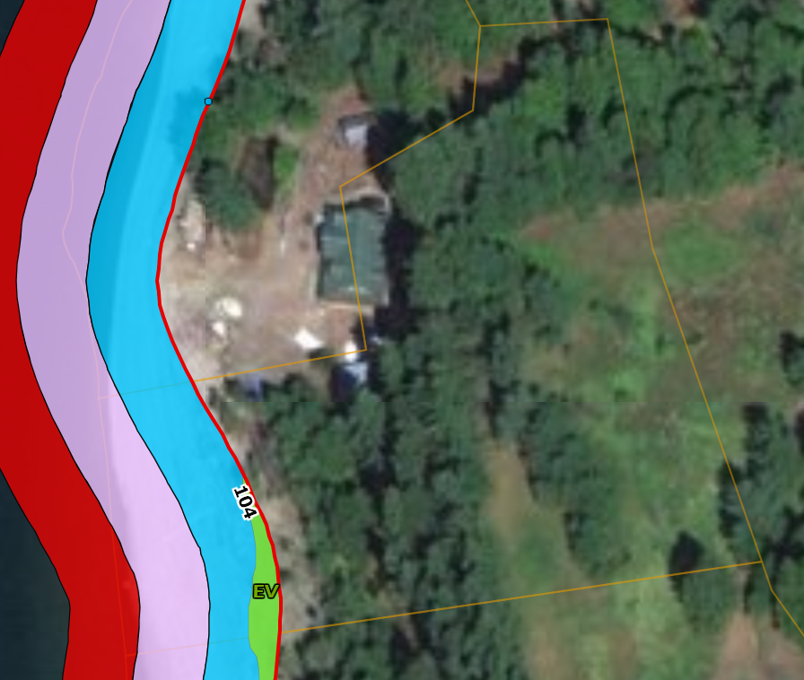
Figure 2: Shoreline Guidance Document mapping

Watercourse Development Permit (WDP) Area

The Official Community Plan directs that development occur in accordance with the following guidelines:
18.5. All development proposals subject to this permit will be assessed by a Qualified Environmental Practitioner (QEP) or Registered Professional Biologist (RP Bio) in accordance with the Riparian Areas Regulation established by the Provincial and/or Federal governments as used elsewhere in the Province.

A Riparian Area Regulation (RAR) report, dated December 20, 2018 was submitted by Iraleigh Anderson, A.Ag and Sylvie Masse, RPBio of Masse Environmental. The report (Schedule 2 of Attachment A) recommended development procedures to protect the integrity of the Streamside Protection and Enhancement Area ‘SPEA’ located 15 m from the high water mark of Kootenay Lake. The measures include:
appropriate scheduling of environmentally sensitive activities, protection of vegetation within the SPEA, sediment and erosion control, storm water management, construction waste management, spill prevention and invasive plant management.

18.6. An WDP shall not be issued prior to the RDCK ensuring that a QEP or RP Bio has submitted a report certifying that they are qualified to carry out the assessment, that the assessment methods have been followed, and provides in their professional opinion that a lesser setback will not negatively affect the functioning of a watercourse or riparian area and that the criteria listed in the Riparian Areas Regulation has been fulfilled.

The report concluded that the authors are qualified to carry out the assessment; and that the assessment methods under the Regulation have been followed; and that, in their professional opinion:

- if the development is implemented as proposed, or
- if the streamside protection and enhancement areas identified in the report are protected from the development, and
- if the developer implements the measures identified in the report to protect the integrity of those areas from the effects of the development,
then there will be no harmful alteration, disruption or destruction of natural features, functions and conditions that support fish life processes in the riparian assessment area.

SECURITY

No landscaping or remedial work was proposed by the QEP. A security of $500 shall be taken to ensure construction is reviewed by the QEP, and all conditions of the permit are met.
SECTION 3: DETAILED ANALYSIS
a. Financial Considerations – Cost and Resource Allocations:
Included in Financial Plan: ☐ YES ☒ NO | Financial Plan Amendment: ☐ YES ☒ NO
Debt Bylaw Required: ☐ YES ☒ NO | Public/Gov’t Approvals req’d: ☐ YES ☒ NO
The $500 fee for the Development Permit application was received.
b. Legislative Considerations (Applicable Policies and/or Bylaws):
This application was reviewed in accordance with the Planning Procedures and Fees Bylaw, which delegates the authority for consideration of Development Permits to the General Manager of Development Services.
c. Environmental Considerations:
The proposed buildings would impact 119.6 m² of riparian habitat, which is outside the 15 meter SPEA (Streamside Protection and Enhancement Area).
d. Social Considerations:
None anticipated.
e. Economic Considerations:
None anticipated.
f. Communication Considerations:
Staff will inform the applicant and the Building Department of the outcome of this process, and will forward both parties comments from FLNROD, Interior Health Authority and the high archaeological potential.
g. Staffing/Departmental Workplan Considerations:
Should the GMDS approve the permit, staff would issue the permit, and register Notice with the Land Title Survey Authority. Building Department staff may then proceed with issuing the Building Permit.
h. Board Strategic Plan/Priorities Considerations:
Not applicable.
SECTION 4: OPTIONS & PROS / CONS
The environmental assessment report highlighted includes recommendations for establishment of a 15 m SPEA and other conditions to protect the riparian habitat. Staff recommend all of the recommendations of the report are included as conditions of the development permit. The options presented for consideration of the General Manager of Development Services (GMDS) are:

Option 1: Approve the proposed Development Permit. This is staff recommendation, as the applicant has met the guidelines as stated in the Official Community Plan.

Option 2: Deny the proposed Development Permit. Staff has not identified any grounds for the Board to deny the proposed permit.

SECTION 5: RECOMMENDATION(S)
That the General Manager of Development Services APPROVE the issuance of Development Permit DP1902D-05680.200-GILL-DP000086 for the property legally described as LOT 1 DISTRICT LOT 6810 and 9039 KOOTENAY DISTRICT PLAN NEP90758 (PID 028-211-189).

Respectfully submitted,

Signature:
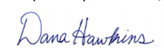
Name: Dana Hawkins, MCIP, RPP
Planner 2
CONCURRENCE Initials:
Planning Manager
General Manager of Development Services

ATTACHMENTS:
Attachment A – Development Permit

